🌍 1. What is an Azure Region?
An Azure Region is a geographical area where Microsoft has one or more data centers.
Example regions:
- Central India
- South India
- West India
- East US
- West Europe
Each region gives you:
- Compute (VMs)
- Storage
- Networking
- Databases
- Security services
- Compliance & data residency

🧩 2. What is inside a Region? (Important)
Every Azure region contains:

✔ a) Availability Zones
- Physically separate data centers
- Protect you from data center failures
- Not available in all regions

✔ b) Paired Regions
Each region is paired with another region for disaster recovery.
Example:
- Central India ↔ South India
- West India ↔ South India

✔ c) Local Zones
For ultra-low latency near a city (not available everywhere).

✔ d) Region-Specific Features
Some services launch first in US/EU before coming to India.

🇮🇳 3. Azure India Regions (Full List)
Azure currently has three primary regions in India:
- Central India – Pune
- South India – Chennai
- West India – Mumbai

⭐ 4. Detailed Information About Each India Region

🇮🇳 Central India (Pune)
- Most commonly used region
- Good connectivity for West, Central, North India
- Supports most Azure services
- Paired Region → South India

🇮🇳 South India (Chennai)
- Good for DR (disaster recovery)
- Paired Region → Central India
- Strong network backbone

🇮🇳 West India (Mumbai)
- Popular for BFSI (Banks, Insurance)
- Strong compliance support
- Lower latency for West India
- Paired Region → South India

⚡ 5. Latency (India Regions)

LOW LATENCY MEANS FAST ACCESSABILITY.
Average latency from Indian cities:
City | Central India (Pune) | West India (Mumbai) | South India (Chennai)
Mumbai | 5–10 ms | 2–5 ms (best) | 15–20 ms
Pune | 2–5 ms | 5–10 ms | 20–25 ms
Delhi | 20–30 ms | 25–35 ms | 30–40 ms
Bangalore | 25–30 ms | 20–25 ms | 5–10 ms (best)
Hyderabad | 15–25 ms | 20–30 ms | 10–15 ms
Best latency region:
- West India → for Mumbai/Pune
- South India → for Bangalore
- Central India → balanced for all

🧑‍💻 6. User Experience Factors
User experience improves based on:
- Low latency
- Region capacity
- Service availability (some services limited in India)
- Azure CDN usage
- General network backbone quality
India regions are stable and fast but some advanced services launch late.

🛡 7. Compliance in India Regions
MEANS THE RULE,SECURITY STANDARD SHOUD BE MEAT
India regions meet important compliance standards:

✔ ISO 27001

✔ SOC 1, SOC 2, SOC 3

✔ PCI-DSS (payments)

✔ HIPAA (healthcare)

✔ GDPR ready

✔ RBI Guidelines (Banks in India)

✔ MeitY empanelment for Govt of India

✔ Data Residency requirements met
So Indian companies like banking, government, insurance can legally store data in Azure India regions.

📍 8. Data Residency for India:-MEANS WHERE DATA IS PHYSICALLY STORED
If you choose any of these regions:
- Central India
- South India
- West India
Then your data stays inside India unless:
- You create DR in another country
- You manually move data outside
Azure does not automatically move your data outside India.

🧰 9. Features of India Regions

✔ Common services available:
- VMs (Windows/Linux)
- Azure SQL
- Azure Kubernetes (AKS)
- Storage accounts
- Key Vault
- VPN Gateway
- Cosmos DB
- App Services
- Load Balancers

✔ Limited / slower rollout in India:
- OpenAI services
- Confidential computing
- Some specialized AI services
- Premium tiers for some services

💰 10. Pricing in India Regions
India region prices are generally:
- Cheaper than US/EU
- Slightly higher than Southeast Asia (Singapore)

Price ranking (low to high):
- East US (cheapest)
- Southeast Asia (Singapore)
- India (mid-level)
- UK, Europe (expensive)
Example:
- A VM might cost ₹4,000/month in East US
- The same VM might cost ₹4,500/month in India
- Because India region has:
  - Higher infrastructure cost
  - Higher power cost
  - Lower data center density

🧠 11. Recommendation — Which region should YOU use?

If you want best latency:
- West India (Mumbai) or
- South India (Chennai) (for Bangalore users)

If you want balanced performance + availability:
- Central India (Pune)

If you need strict data residency:
- Choose any India region only.

If you want lowest price:
- Choose East US, but data will leave India (not allowed for many companies).

2)resource prise: -
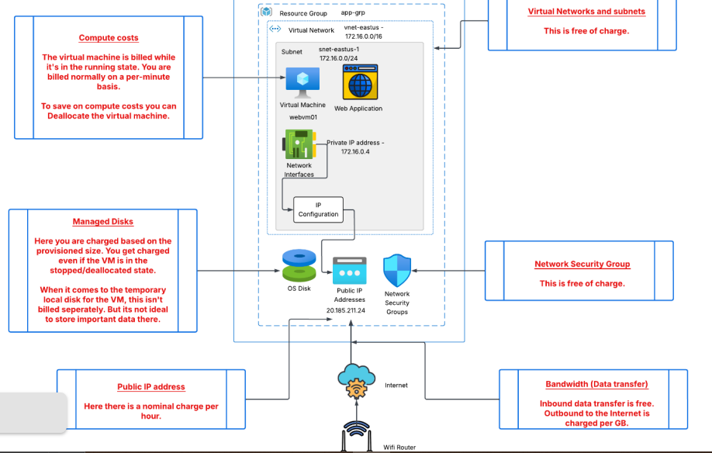
3)how to set budget alert:-
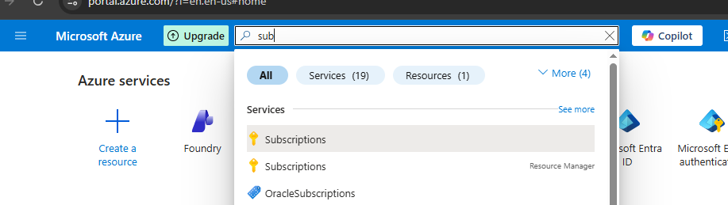Go to the subscription
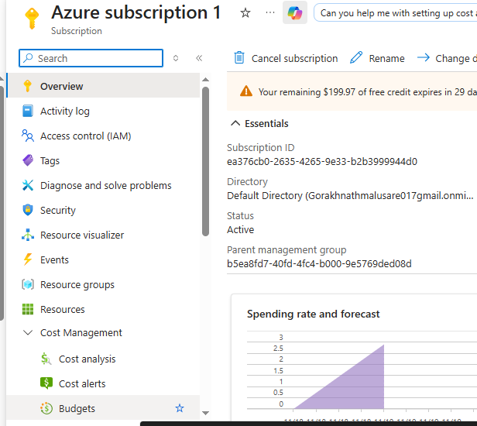
IN COST MANAGEMENT-BUDGET-

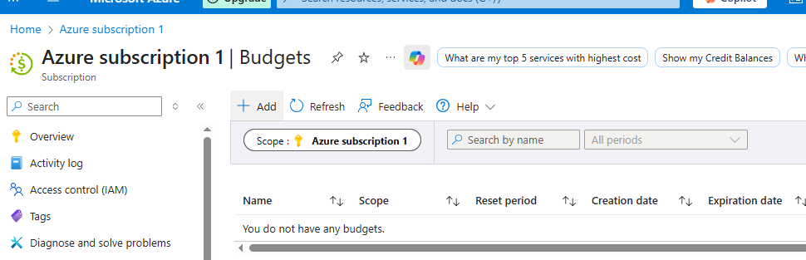
ADD BUDGET:-
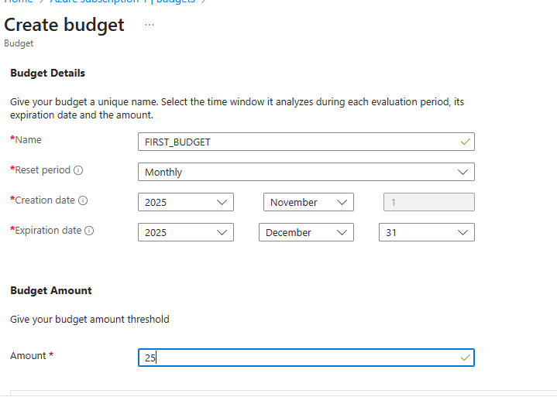
ADD NAME,RESEAT PERIOD,DATE AND BUDGET THRESHOD.
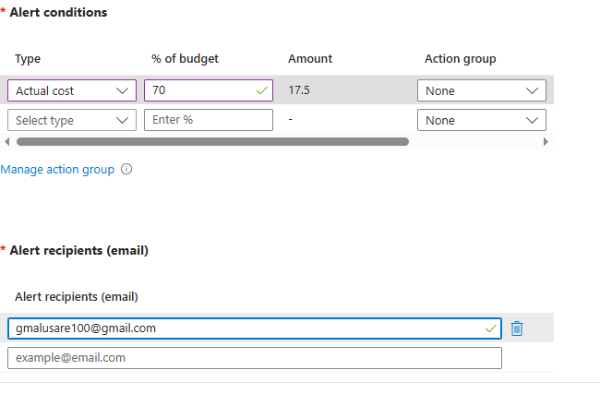
Add alert condtion that if the amount is near the threshold like 70% reach to the specified threshold that mail on specified email.

4)if u want to see the cost of what u used :- go to the cost analysis where u can see from where and how much each resource cost u.
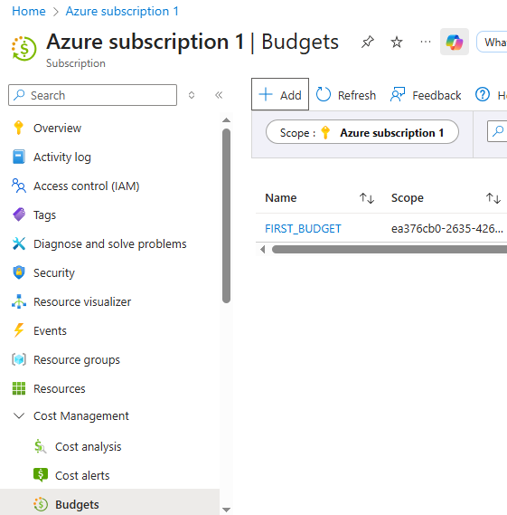

5)VM disk size:-
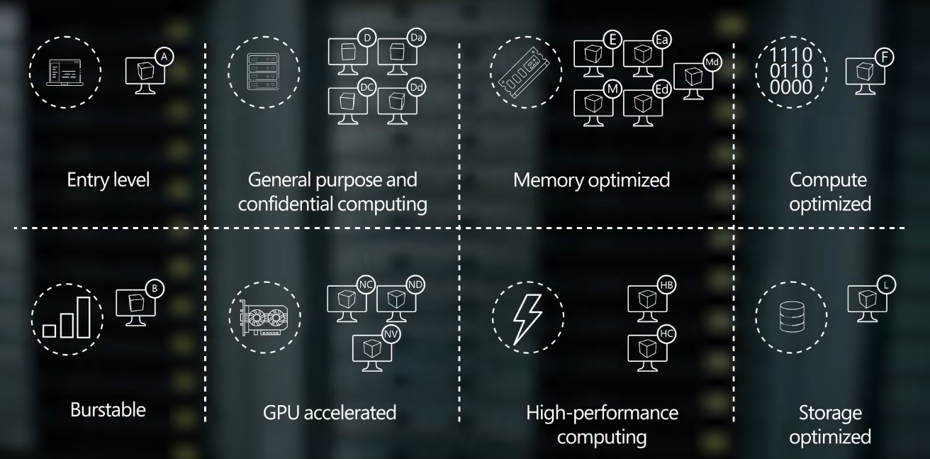

✅ Why Azure VM Sizes Show Intel & AMD Processor Types
When you choose a VM size in Azure (like D-Series, E-Series, F-Series, etc.), you will sometimes see:
- Intel-based CPUs
- AMD-based CPUs
This is because Azure uses physical servers in Microsoft data centers, and those servers come with different processor brands/models.
Azure gives you the option to run your VM on whichever processor type you prefer (if that VM size supports multiple).

🔥 What’s the Difference?

1. CPU Architecture & Performance
Different processors deliver different performance levels:
Processor | Known For | Example Azure VM series
Intel Xeon | High single-core performance; best for apps needing fast per-core speed | Dv3/Dv4, Ev3/Ev4, F-series
AMD EPYC | More cores at lower price; great multi-core workloads | Dav5/Dsv5, Eav5/Esav5

6)types of VM size:-
✅ 1. Entry-Level (A-Series)
Purpose: Very basic workloads, lowest cost.
Use-cases:
- Small websites
- Small development servers
- Testing VMs
- Lightweight applications
Example VMs:
- A1, A2, A3
- Av2 Series
✔ Cheapest VMs in Azure
✔ Good for practice and labs

✅ 2. General Purpose & Confidential Computing (D-Series, DC-Series)
Balanced CPU + Memory

General Purpose
Use-cases:
- Web servers
- Application servers
- Small to medium databases
- Backend APIs
- Business apps
Example:
- D-Series (Dv3, Dv4, Dv5)
- Das_v5 / Dsv5 (AMD or Intel)

Confidential Computing (DC-Series)
Used when data must stay encrypted while processing.
Use-cases:
- Banking
- Government
- High-security workloads
Example:
- DCsv3, DCsv2

✅ 3. Memory Optimized (E-Series, M-Series)
These have high RAM compared to CPU.
Purpose: Workloads requiring large memory.
Use-cases:
- Large databases (SQL, MySQL, PostgreSQL)
- In-memory caches (Redis)
- Analytics
- SAP HANA (M-series)
Example:
- E-Series (Ev3, Ev4, Ev5)
- Ea_v5 (AMD)
- M-Series (Huge RAM: 4 TB–12 TB)

✅ 4. Compute Optimized (F-Series)
High CPU power per memory.
Use-cases:
- High performance web servers
- CPU-intensive apps
- Gaming servers
- Batch processing
- Analytics workloads
Example:
- F-Series
- Fsv2
✔ More CPU per ₹
✔ Ideal for compute-heavy workloads

✅ 5. Burstable VMs (B-Series)
These VMs "burst" CPU when needed and cost less when idle.
Use-cases:
- Low traffic websites
- Dev/test servers
- Small apps
- Occasional CPU spikes
Example:
- B1s, B2s, B4ms
✔ Saves money
✔ Good for students and testing

✅ 6. GPU Accelerated (NC, ND, NV Series)
Have NVIDIA GPUs for heavy graphics or AI.

Use-cases:
- Machine Learning
- Deep Learning
- AI model training
- Video rendering
- Gaming/desktop virtualization
Example:
- NC-series → Compute GPU
- ND-series → Deep learning GPU
- NV-series → Graphics/Virtual desktops

✅ 7. High-Performance Computing (HB, HC Series)
Designed for supercomputing workloads.
Use-cases:
- Scientific simulations
- Weather modeling
- Fluid dynamics
- High-performance engineering workloads
Example:
- HB-series
- HC-series
✔ Extremely high network + CPU throughput
✔ Very expensive, for advanced workloads

✅ 8. Storage Optimized (L-Series)
High disk I/O throughput.
Use-cases:
- Big Data
- Large NoSQL Databases (Cassandra, MongoDB)
- Data warehousing
- Log processing
Example:
- Lsv2
- L8s, L16s, L32s
✔ Very fast local SSD
✔ Best for storage-heavy workloads

⭐ Quick Summary Table
Category | Series | Best For
Entry Level | A | Small apps, testing
General Purpose | D, DC | Web/app servers, medium DBs, secure workloads
Memory Optimized | E, M | Large DBs, memory-heavy apps
Compute Optimized | F | CPU-heavy apps
Burstable | B | Low-cost VMs with occasional spikes
GPU | NC, ND, NV | AI, ML, graphics
HPC | HB, HC | Research, simulations
Storage Optimized | L | Big data, high disk workloads

✅ How Burstable VMs Work (Simple Explanation)
A Burstable VM normally uses very low CPU.
Because you are not using full CPU all the time, the VM starts saving CPU credits.
Later, when you suddenly need high CPU power, the VM will use those saved credits to “burst” to 100% CPU.
So:

Low usage = save credits

High usage = spend credits.This is why B-series is cheaper than other VMs.

